UNIT Two – Notes #6- DRIVERS OF EVOLUTION

Evolution simply means that species are genetically changing over time !
Original Population of Frogs – Let "G" = Dominant dark Green colour, while "g" is recessive for yellowish green colour.
GG | Gg | GG | gg | gg
Gg | Gg | GG | Gg | GG
gg | gg | GG | Gg | Gg
Gg | gg | Gg | GG | gg
Total Alleles - 20 frogs with two alleles each = 40
20/40 Alleles are "G" = 0.50 allelic frequency – 50%
20/40 Alleles are "g" = 0.50 allelic frequency – 50%
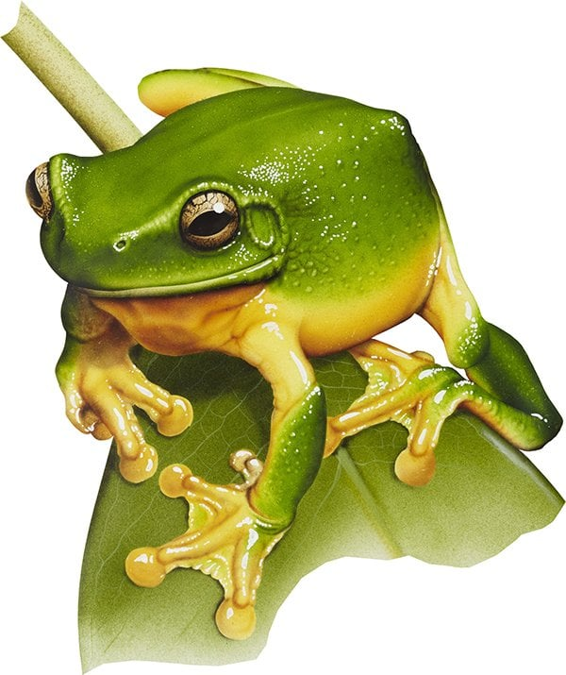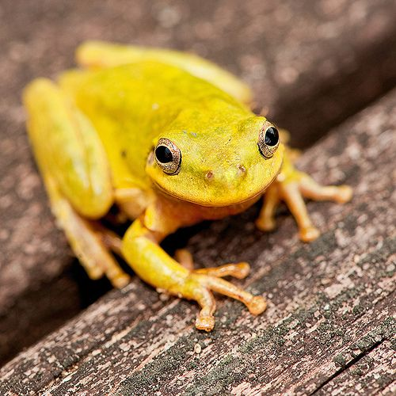
Yellowish
Dark Green
*** When certain conditions are maintained, such as:
A) Large Population D) No Differential Migration
B) Random Mating E) Equal viability (survivability)
C) No new Mutations
A Gene pool for a species can get locked in so that evolution does not take place. During this time, the gene pool is said to be in a state of "GENETIC EQUILIBRIUM"
- Usually that state does not last very long as the environment changes and the factors listed above may start to come into play. Then the gene pool will undergo EVOLUTION.
- Here are some of the main drivers of evolution:
DRIVER # 1 – NATURAL SELECTION

Imagine that light yellowish green is advantageous. Then "gg" frogs will live longer and reproduce more offspring. What will happen?
A few generations later, we will see the following:
gg | gg | Gg | gg | gg
gg | Gg | Gg | gg | Gg
gg | gg | Gg | Gg | gg
Gg | gg | gg | Gg | gg
Now the allelic frequencies are as follows:
Allelic frequency for "G" = 8/40 20%
Allelic frequency for "g" = 32/40 80%
Evolution through Natural Selection has occurred.
Driver #2 – MUTATION

In this case a brand new form of the gene shows up through a mutation to the sequencing of DNA for that gene. This new allele may be either recessive or dominant. Imagine that it codes for Brown colour.
After a few generations
Gb | Gg | GG | gg | gg
Gg | Gg | GG | Gg | Gb
gg | gg | Gb | Gg | Gg
bb | gg | Gg | GG | gb
Now the allelic frequencies are as follows:
Allelic frequency for "G" = 16/40 40%
Allelic frequency for "g" = 18/40 45%
Allelic frequency for "b" = 6/40 15%

DRIVER #3 – GENETIC DRIFT
Both alleles are equally favoured, and both dark green and yellowish green are both equally fit for the environment. But, for no good reason at all, the random mating and random union of sex cells ends up with the "G" getting passed down more frequently.
A couple of generations later
GG | Gg | GG | gg | gg
Gg | Gg | GG | Gg | GG
Gg | Gg | GG | Gg | Gg
GG | gg | Gg | GG | Gg
Now the allelic frequencies are as follows:
Allelic frequency for "G" = 24/40 60%
Allelic frequency for "g" = 16/40 40%

Driver #4 – SELECTIVE MATING
Yellowish green is pretty ATTRACTIVE to potential mates !
In a way this could be considered a very specific type of Natural Selection, because yellowish green are being selected as favoured.
After a few generations
Gg | gg | Gg | gg | gg
gg | Gg | Gg | Gg | Gg
gg | gg | Gg | Gg | gg
GG | gg | gg | Gg | Gg
Now the allelic frequencies are as follows:
Allelic frequency for "G" = 12/40 30%
Allelic frequency for "g" = 28/40 70%

DRIVER #5 – DIFFERENTIAL MIGRATION
In this case a few frogs move out (Emmigrate) of the population and a few new frogs move in (Immigrate) into the existing population. But the phenotype of the ones that leave, don't equal the phenotypes of the ones that enter. Perhaps they swim across a very wide lake when they get caught up in a strong windstorm.

Imagine that the following frogs leave: gg, Gg gg gg
And the following frogs enter: GG, Gg GG GG
- Quite a few yellow alleles leave the gene pool, while quite a few green alleles enter.
GG | Gg | GG | GG | gg
Gg | Gg | GG | Gg | GG
GG | gg | GG | Gg | Gg
Gg | gg | Gg | GG | GG
Now the allelic frequencies are as follows:
Allelic frequency for "G" = 26/40 65%
Allelic frequency for "g" = 14/40 35%

DRIVER #6 – FOUNDER EFFECT – Bottle Neck
In this case something happens where a small group breaks off or a small group survives some major environmental change. And the allelic frequencies are different than they were in the original population. During this event, it's just by chance that a very small number of organisms survive, maybe only 5% of population survive. But that 5% that survive now have a gene pool that is quite different than the original gene pool found in the larger population.

Example – Forest Fire – Green equals survivors
Red (underlined) equals – DEAD members
GG | Gg | GG | gg | gg
Gg | Gg | GG | Gg | GG
gg | gg | GG | Gg | Gg
Gg | gg | Gg | GG | gg
Now the allelic frequencies are as follows:
Allelic frequency for "G" = 1/8 12.5%
Allelic frequency for "g" = 7/8 87.5%

*** Flip over to the back of this page and use your critical thinking to answer the discussion question regarding the article "It Runs In The Family- Backward"

