**Unit TWO Review #1 Q’s KEY**

1. **Some key evidence of evolution include-**
2. **Fossil Record  
   A poster with different animals

   Description automatically generated with medium confidence**
3. **Embryonic Similarities  
   A chart of different types of embryos

   Description automatically generated**
4. **Homologous Structures.  
   A diagram of bones and bones of a human body

   Description automatically generated**
5. **Vestigial Organs**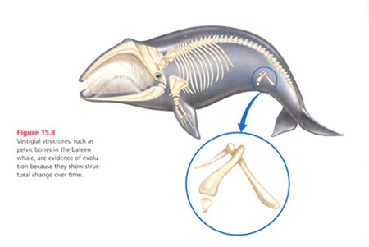
6. **Biochemical Similarities  
   Universal DNA, Protein Amino Acids, ATP**
7. **Biogeographical Evidence**[](http://www.google.ca/imgres?hl=en&biw=1008&bih=511&tbm=isch&tbnid=vgp5vDprUw6v0M:&imgrefurl=http://www.universetoday.com/73678/what-is-pangea/&docid=4Hm88jfvK-VBgM&imgurl=http://d1jqu7g1y74ds1.cloudfront.net/wp-content/uploads/2009/08/Pangea_animation_03.gif&w=200&h=160&ei=pqlEUvWcIMvoiALspYGADQ&zoom=1&iact=rc&dur=109&page=1&tbnh=128&tbnw=103&start=0&ndsp=16&ved=1t:429,r:12,s:0,i:113&tx=68&ty=71) **A diagram of ostriches and birds

   Description automatically generated**
8. **Modern Observed Cases-Ex. Peppered Moth**

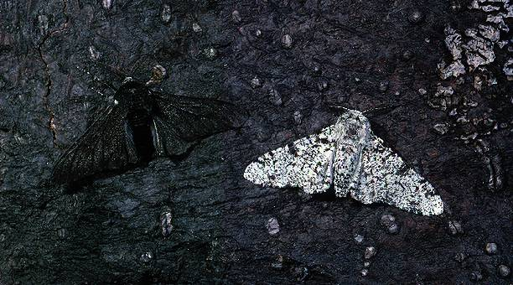

1. **The HMS Beagle and it set sail in 1831**
2. **Around SOUTH AMERICA and the GALAPAGOS ISLANDS**

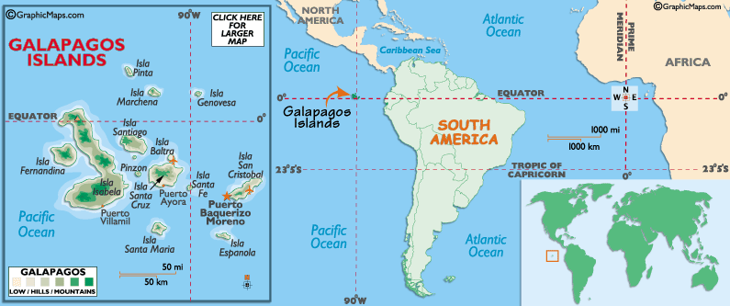

1. **As the Ship sailed south, Darwin noted that species had slightly modified structures, behaviours etc. (adaptations) that helped them survive in slightly different environments.**
2. **Darwin believed that the ENVIRONMENT was influencing the changes he noted in the organisms. Species seemed perfectly adapted to their specific environment.**
3. **Beak shape and size as well as bird colouration varied from species to species. He believed that the beak shape structure was influenced by the type of food available to the finches.**

**See Picture Below**

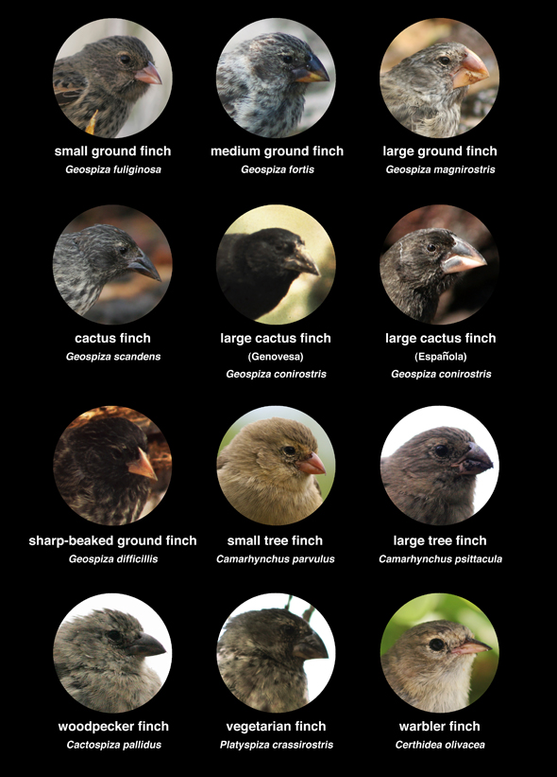

1. **Farmers have completely altered the structural, behavioural and physiological adaptations of their livestock and crops through SELECTIVE BREEDING (Artifical Selection)**

**For Example this dog – this dog would never survive in the wild.**

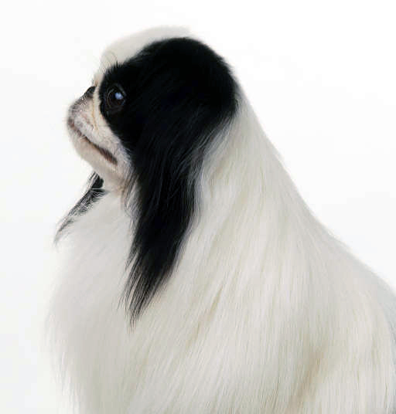 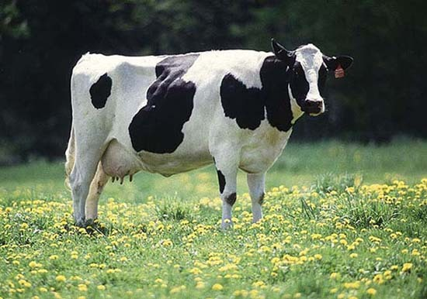

1. **The Theory that states that members of populations compete against each other for resources and survival. The members with the best adaptations are most fit and they survive and pass those genes onto the next generation. And so on…**

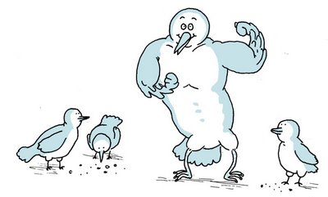

1. **Members that do NOT have the best adaptations, they tend to die out and the genes they posses are eventually weeded out of the gene pool in that population. Ex. Albino Moose is too easy to spot!**

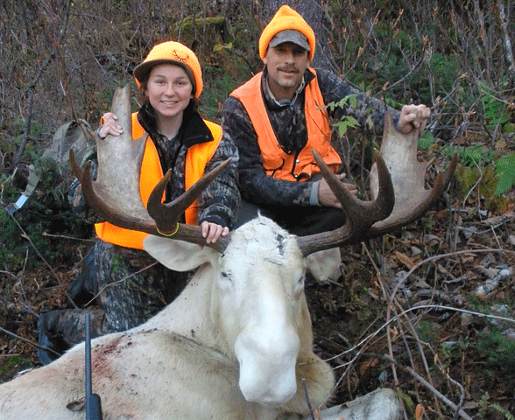

1. **Long Legs of a frog would have evolved from frogs competing against one another for escaping predators (fish and heron etc). The frogs with the strongest/longest legs could out-compete those frogs with shorter/weaker legs. Those with webbing should theoretically be better swimmers.**

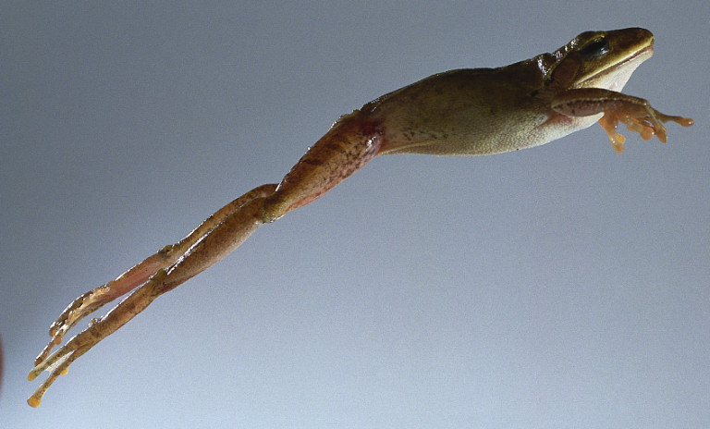

1. **ADAPTATIONS help organisms survive and fit into their specific environment and pass those traits down to their offspring.**
2. **STRUCTURAL ADAPTATION – A physical structure an organism possesses for survival.**

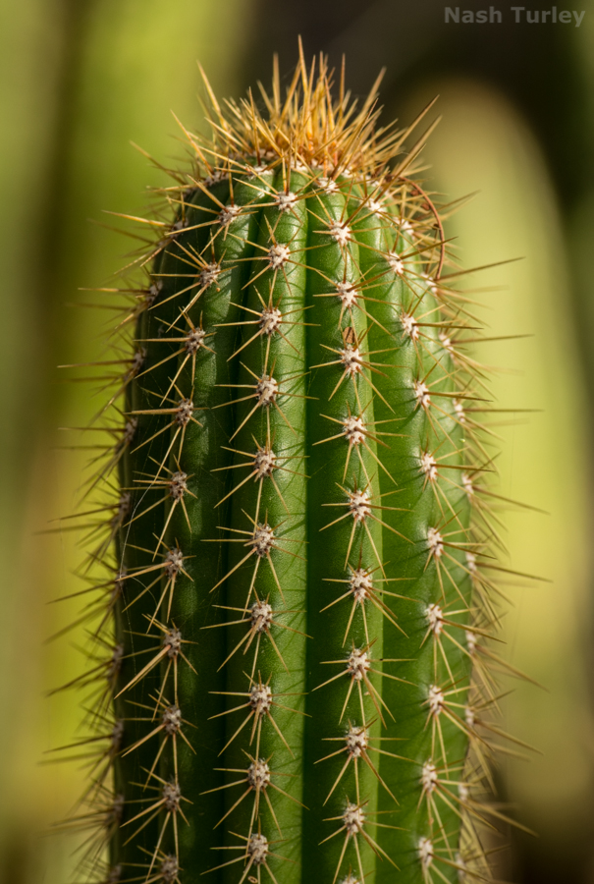

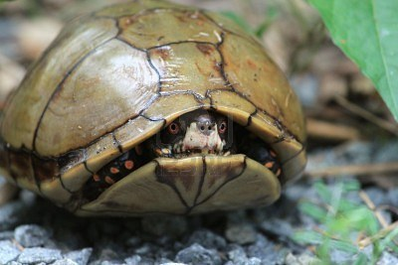

1. **BEHAVIOURAL ADAPTATION – A behaviour that helps an organism survive.**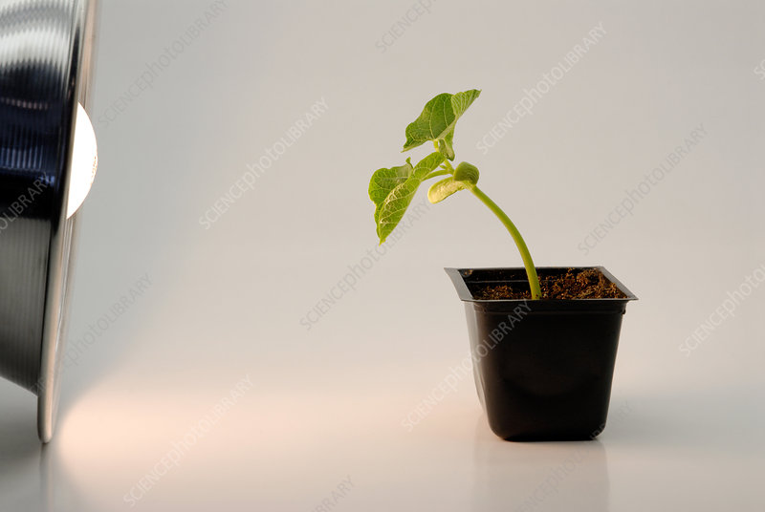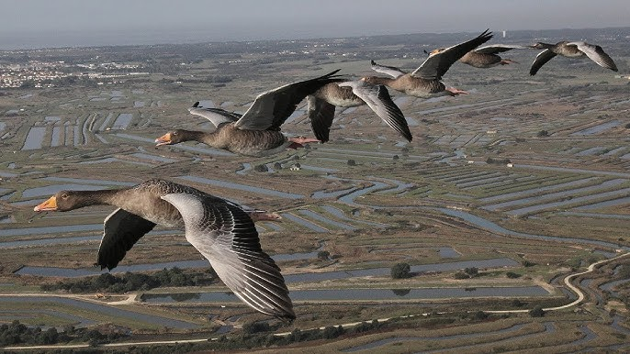

MIGRATION

1. **PHYSIOLOGICAL (Functional) ADAPTATION – A cellular metabolic process that creates pigments, toxins, enzymes or other chemicals that give an organism an advantage. Enzymes in Flytrap**

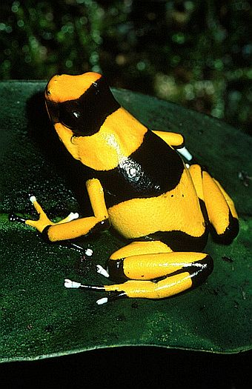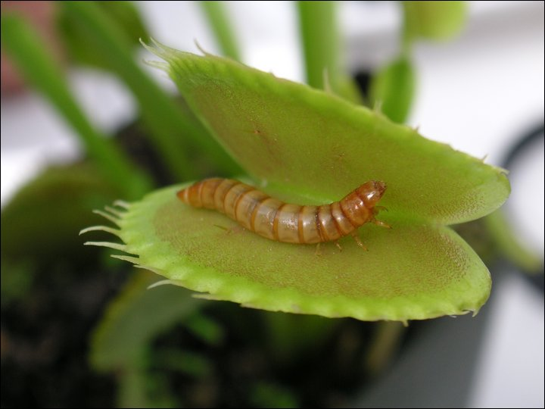

1. **DIRECTIONAL SELECTION – in this graph, the extreme phenotype to the right of the normal distribution is favoured.**

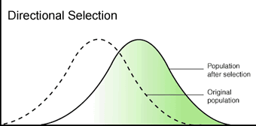

1. **DISRUPTIVE SELECTION – Both extremes are favoured below.**

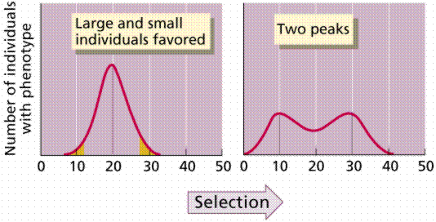

1. **STABILIZING SELECTION – Both extremes are weeded out.**

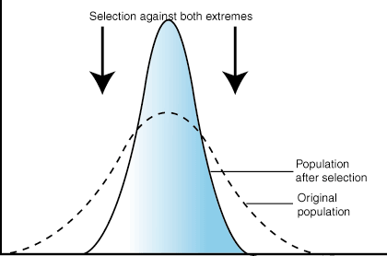

1. **DISRUPTIVE Selection Examples:**

**DEER MOUSE – Darker Woodlands Mouse and Lighter Field Mouse.**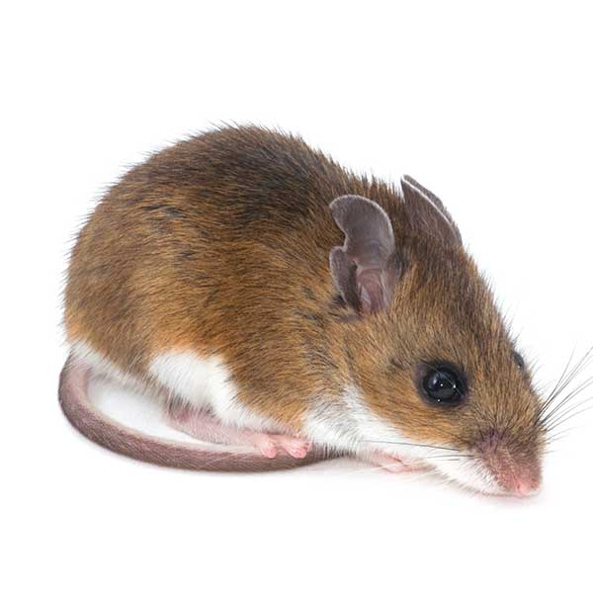

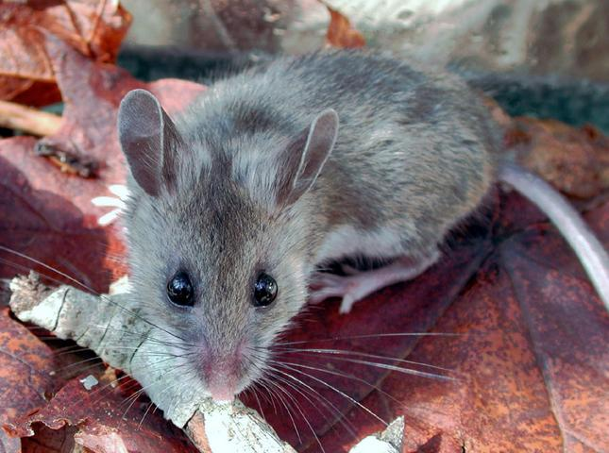

1. **DIRECTIONAL Selection Examples : DDT resistant mosquitoes and modern day horses increased size, melanic (dark) peppered moth, antibiotic resistant bacteria.**

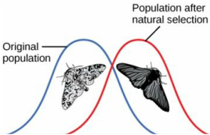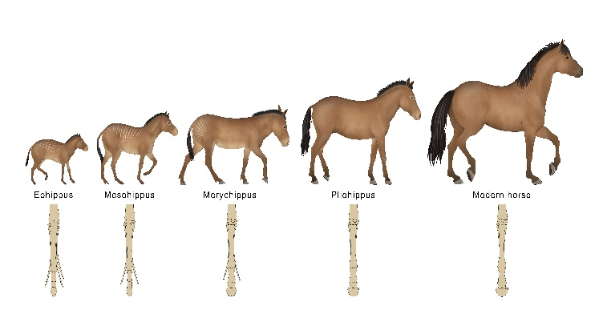

1. **Stabilizing Selection Examples : Normal Mating Rituals, Normal Birth weights, Normal colouration patterns, number of eggs laid by birds.**

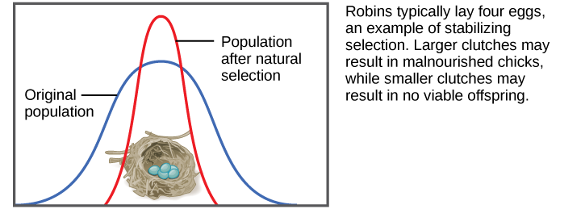

**SUMMARY below**

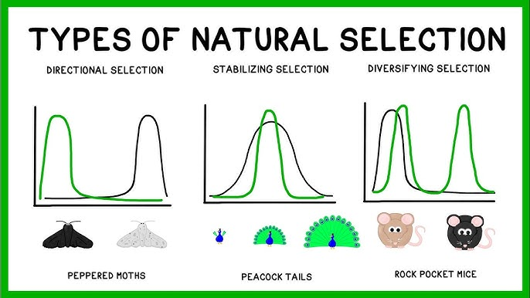

1. **DISRUPTIVE Selections – may give rise to two different species.**
2. **Lamarck theorized the "INHERITANCE OF ACQUIRED CHARACTERISTICS"**
3. **One of Lamark's experiments involved amputation of mouse tails for successive generations, showing that even after twenty generations, there was no effect: baby mice were still born with tails. Another example, to make the fallacy of his theory more apparent, would be two people who developed large arm muscles because they were blacksmiths, tennis players, or weight-lifters having a baby who was born with larger than normal arm muscles.**
4. **“INDUSTRIAL MELANISM” Before the Normal “Peppered” phenotype was favoured. After the Industrial Revolution took effect the “Melanic” moth became favoured.**

* **See pictures below**

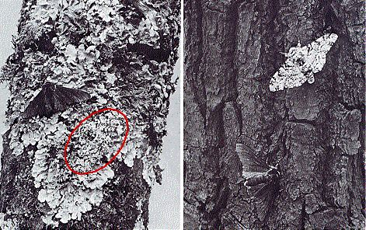

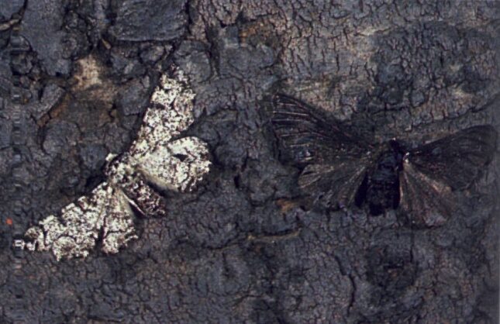

1. **PHENOTYPE is the physical observable characteristic/trait that an organism possesses. Example – BROWN EYES**

* **GENOTYPE – The genetic makeup of an individual that gives rise to the phenotype. Example brown eye genotypes – BB or Bb**

1. **A) 15/50 alleles are "L" = 30%**

**35/50 alleles are "l" = 70%**

**B) 14/25 Hamsters are Long Tailed = 56%**

**11/25 Hamsters are Short Tailed = 44%**

1. **13/25 hamsters are "Ll" = 52%**

**1/25 hamsters are "LL" = 4%**

**11/25 hamsters are "ll" = 44%**

1. **If a Heterozygous Long-tailed hamster "Ll" mates with a Short-Tailed hamster "ll"**

|  |  |  |
| --- | --- | --- |
| **X = cross** | **L** | **l** |
| **l** | **Ll** | **ll** |
| **l** | **Ll** | **ll** |

**The Genotypic Ratio = 50% Ll : 50% ll**

**DISCUSSION QUESTION- See below**

**Imagine that humans have to run through dense bush and forests covered with deadfall (knocked over logs) in order to escape predators. Perhaps these mutants have a reduced risk of spraining ankles and knee joints than other normal humans.**

**Another suggestion:**

**What if these mutants could run away from predators without having to turn their back on the predator to do so.**