UNIT THREE INTRO REVIEW - Assignment:
For each question, select the best answer and highlight that response with a bright colour. You may want to use my website to find scanned textbook pages, PowerPoints etc.
- In biology, the branch of science that involves that classification of organisms is known as…
A) Taxonomy
B) Virology
C) Binomial Nomenclature
D) Evolution
2. Bacteria use what type of cell?
A) Eukaryotic cells
B) Prokaryotic cells
C) Both Eukaryotic and Prokaryotic cells are found in bacterial kingdoms
D)Abiotic Cells
3. The scientific naming system known as BINOMIAL NOMENCLATURE, was developed by:
A) Louis Pasteur
B) Jean Baptiste Lamarck
C) Carl Linnaeus
D) Edward Jenner
4. One simple tool that biologists often use out in the field to help identify and classify organisms, such as plants and animals is a…
A) DNA Sequencing atomizer
B) Dichotomous Key
C) Tracheotomy Tree
D) Phylogenetic Tree Chart
5. How many Kingdoms are in the system we will be using to study LIFE?
A) Three
B) Four
C) Five
D) Six
E) Seven
6. The image below, best depicts what type of cell?
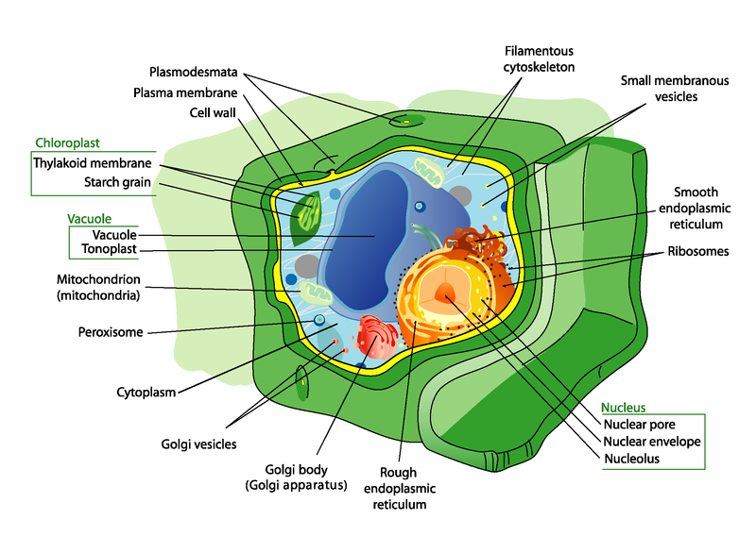
A) A prokaryotic animal cell
B) A prokaryotic fungal cell
C) A eukaryotic animal cell
D) A eukaryotic fungal cell
E) A eukaryotic plant cell
7. The cell shown below could belong to which KINGDOM?
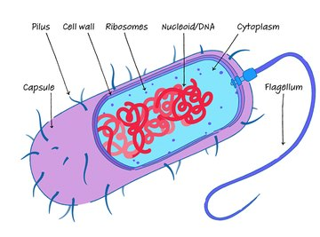
- FUNGI
- EUBACTERIA
- PLANTAE
- ANIMALIA
- PROTISTA
8. This unicellular eukaryotic Amoeba, would belong to which KINGDOM?
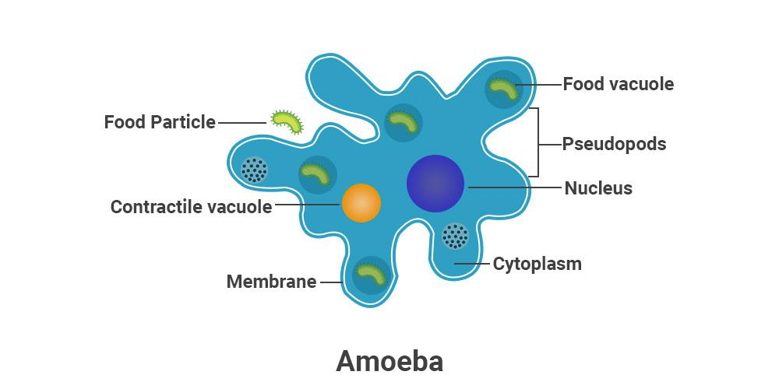
A) PROTISTA
B) ANIMALIA
C) FUNGI
D) ARCHAEBACTERIA
E) PLANTAE
9. If an organism is multicellular, has eukaryotic cells and the cells have a cell wall made of CHITIN, what KINGDOM will that organism belong to?
A) ARCHAEBACTERIA
B) EUBACTERIA
C) PROTISTA
D) FUNGI
E) PLANTAE
10. If an organism is multicellular, has eukaryotic cells and the cells have a cell wall made of CELLULOSE, what KINGDOM will that organism belong to?
A) ARCHAEBACTERIA
B) EUBACTERIA
C) PROTISTA
D) FUNGI
E) PLANTAE
11. What best describes the cells found in your body?
A) Prokaryotic cells that contain a cell wall made of PEPTIDOGLYCAN
B) Eukaryotic cells that contain a cell wall made of CELLULOSE
C) Eukaryotic cells that contain a cell wall made of CHITIN
D) Eukaryotic cells that do not contain a cell wall at all.
12. What KINGDOM do Humans belong to?
A) ANIMALIA
B) PROTISTA
C) PLANTAE
D) ARCHAE
E) FUNGI
13. Which of the following is the proper way to scientifically name Human beings?
A) Homo Sapiens
B) Homo SAPIENS
C) homo Sapiens
D) Homo sapiens
E) Homo sapiens
14. Which of the following list the 7 TAXA in their order from most General to most Specific?
A) Species Genus Family Order Class Phylum Kingdom
B) Kingdom Class Phylum Order Genus Family Species
C) Kingdom Phylum Class Genus Order Species Family
D) Kingdom Phylum Class Order Family Genus Species
E) None of the above represents the correct order of Taxa
15. Animals with backbones belong to which PHYLUM?
A) Chordata
B) Chelicerata
C) Arthropoda
D) Porifera
E) Cnidaria
16. The image below, represents a…
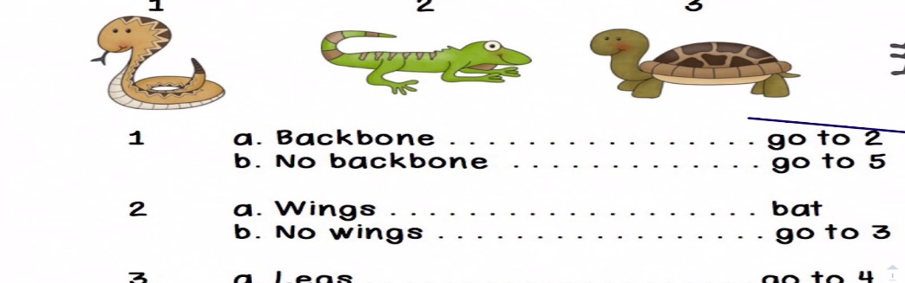
- Venn Diagram
- Taxonomic Divergent Chart
- Taxa Management Spreadsheet
- Dichotomous Key
- Zoological Flow Chart
17. According to our lesson on how to use the tool mentioned above in questions #16, what was this organism?
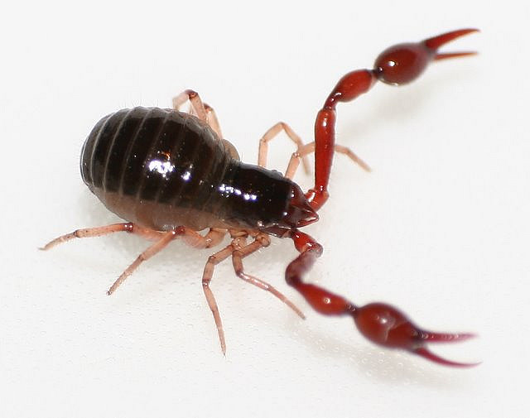
A) A Whiptail Scorpion
B) A Silverfish
C) A Scorpion Tick
D) A Pseudoscorpion
E) A Crawdaddy
18. What KINGDOM of life do Viruses belong to?
A) Archaebacteria
B) Eubacteria
C) Protista
D) Fungi
E) They do not belong to a kingdom as they do not meet all the criteria to be a true organism.
19. Viruses contain which of the following?
A) Only DNA
B) Only RNA
C) Neither DNA or RNA
D) Either DNA or RNA
20. When a virus is not inside a host cell, it is properly called a…
A) Prion
B) Virion
C) Prius
D) Alpha
E) Genome
21. Viruses that attack and infect prokaryotic organisms are classified as…
A) Monocytes
B) Bacteriophages
C) Vectors
D) Nucleoids
E) MRSAs
22. Which of the following is NOT a type of virus SHAPE?
A) Polyhedral
B) Complex
C) Octagonal
D) Spherical
E) Complex
23. A virus that contains RNA as its Nucleic Acid is categorized as being a…
A) Inverted Virus
B) Translocated Virus
C) Anointed Virus
D) Retro Virus
E) None of the above
24. Which viral shape is shown below?
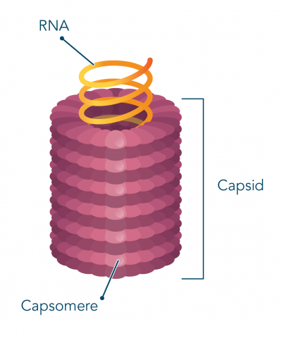
- HELICAL
- SPHERICAL
- COMPLEX
- POLYHEDRAL
- OCTAGONAL
25. In a virus, the capsid is made out of….
A) Protein
B) DNA
C) RNA
D) Carbohydrate
26. Which of the following is a DNA Virus?
A) SARS CoV-2 that causes COVID 19
B) HIV that causes AIDS
C) An Adenovirus that causes a common cold
D) Rotavirus that causes severe diarrhea
27. Many viruses contain spikes on their outer envelope, what is the main function of these spikes?
A) To allow them to attach onto host cells
B) For them to communicate with other viruses
C) For protection from predatory white blood cells
D) They actually serve no purpose, they are just there.
28. The destruction of which crop triggered scientists to dig deeper into their study and discovery of what viruses are?
A) Tomato crops C) Potato crops
B) Corn crops D) Tobacco crops

29. The image below depicts one type of Viral Life Cycle used by some types of viruses, what is this life cycle called?
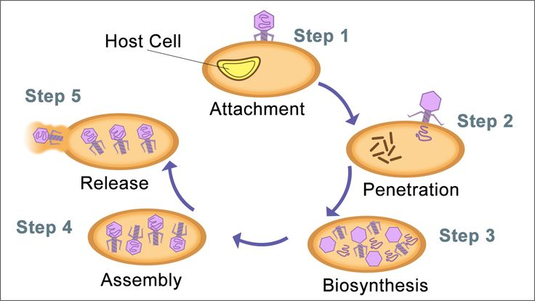
A) Lytic Cycle
B) Lysogenic Cycle
C) Cryptic Cycle
D) Tactical Destructive Cycle
E) Obliterative Beatdown Cycle
30. Use Google to help you determine which of the following diseases is NOT cause by a virus?
A) Rabies
B) Polio
C) Tuberculosis it is BACTERIAL
D) Influenza
31. Which of the following is NOT true regarding Viruses?
A) Viruses cause much disease in humans, livestock and crops.
B) Viruses can damage bodily tissue, which can cause certain types of cancer.
C) Viruses can be used by scientists to genetically improve crops.
D) Viruses can be used in Immunotherapy treatment against cancer.
E) All of the above are true, when it comes to viruses.

32. In a LYSOGENIC LIFE CYCLE, when the Viral DNA is incorporated into the host cell's DNA and is waiting to get copied (replicated), what is the proper term for this inactive viral DNA that is incorporated into the host cell's DNA?
A) Virulent Phage
B) Prophage
C) Retrovirus
D) Macrophage
33. What descriptor below, best defines a VIRUS?
A) An abiotic parasite
B) A biotic parasite
C) An abiotic consumer
D) A biotic consumer
THE END

