UNIT 3 Rev #1 KEY
LO - 1
- Eukaryotic cells posses a true NUCLEUS and membrane-bound ORGANELLES and they are much smaller than Eukaryotic cells.
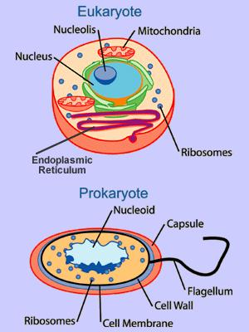
- Most chemical reactions occur inside organelles, this allows the cell to be more efficient with its reactions by organizing which enzymes should work together with each other to get chemical reactions done more efficiently.

- Eukaryotic cells compartmentalize processes and reactions (allowing specific reactions to be coupled to other specific reactions), while Prokaryotic reactions just happen all over the place.

- Prokaryotic organisms belong to KINGDOMS– Kingdom Archaebacteria
- Kingdom Eubacteria.

LO - 2
- The three main bacterial shapes are :
- COCCI B) BACILLI C) SPIRILLUM
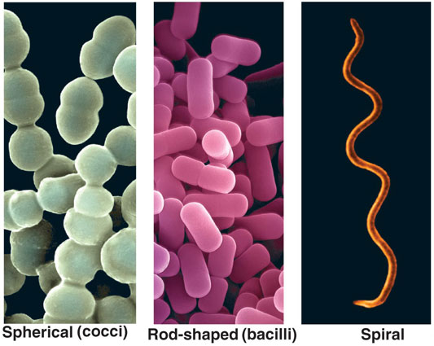
- A COLONY
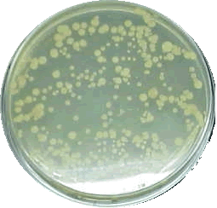
Several separate visible colonies growing on this Petri dish. Each colony contains billions of bacteria
- Staphylococcus would look like groups/clumps of spherical bacteria.
Streptococcus would look like short and long chains of spherical bacteria.
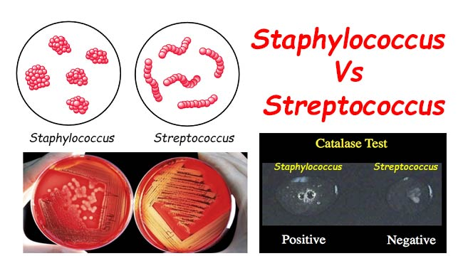

- PEPTIDOGLYCAN
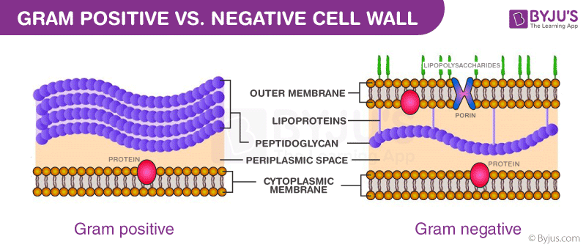
- GRAM Negative = THIN cell wall, stain PINK/red, absorb SAFRANINE. With their outer modified membrane, they are more resistant to most antibiotics.

- Gram Positive = THICK Cell wall, Stain PURPLE, absorb CRYSTAL VIOLET.

- Gram Negative – SAFRANINE - Pink
Gram Positive – Crystal Violet – Purple
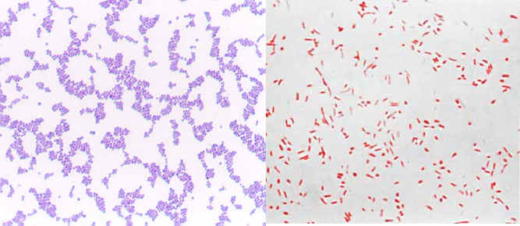
- Archaebacteria are adapted to live in extreme environments : Extreme Acidic, Extreme Salty, Extremely High Temperatures, Low O₂ – Anaerobic.
- Less standard way of obtaining energy.
- Cell wall does not have Peptidoglycan.
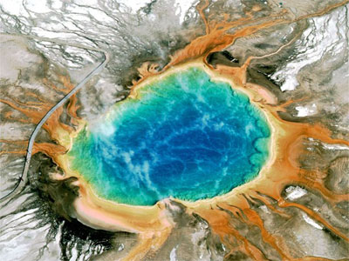
- PILI help bacteria adhere to other surfaces and for transferring DNA between each other.
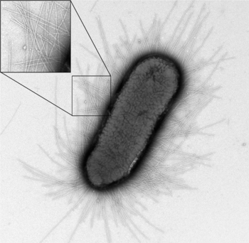

- Here are some various bacterial diseases:
A) Tuberculosis
- Leprosy
- Bacterial Pink Eye
- Lyme Disease
- Strep Throat
- Tetanus
- Whooping Cough (Pertussis)
- Flesh-Eating Disease – Necrotizing Fasciitis
- Along with several types of food poisoning (Botulism, Salmonella and E-Coli)

- Generally, most antibiotics either:
A) Inhibit cell wall synthesis.
B) Shut down the ribosomes of prokaryotes
C) Block enzymes that prokaryotes use, example enzymes that the cells may use to copy their DNA.

- It is essential that antibiotics are taken exactly as prescribed, so that all of the bacteria, even the hardier resistant bacteria are killed by the antibiotic, not just the ones that are killed out in the first few days. If not, the resistant ones are left behind to pop up a more resistant strain. These more resistant strains may need higher level antibiotics, or they may not even respond to any antibiotic we currently have. This causes the development of Super Bugs.
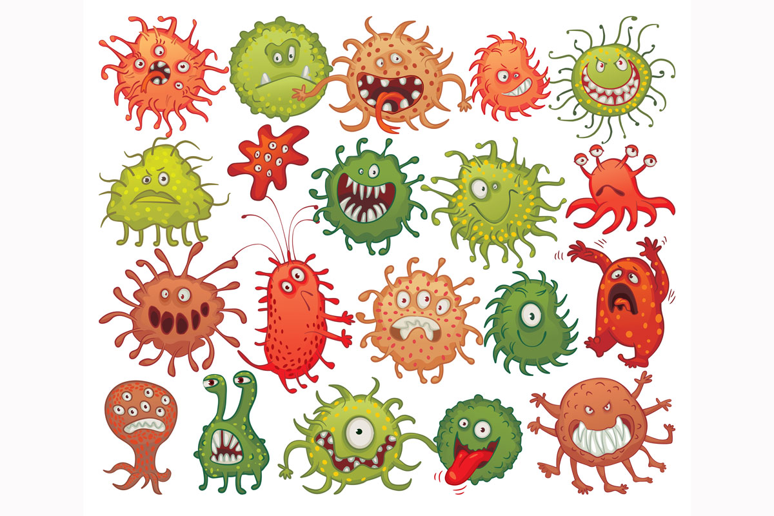
- Bacteria also serve beneficial roles such as:
- Decomposers in the environment
- Sewage treatment
- Oxygen production in aquatic environments
- Good gut health
- Food industry – Cheese, yogurt etc
- Breaking down oil spills
- Producing new antibiotics
- Used in medicine to manufacture key proteins – like INSULIN

- The image shows a species of STREPTOCOCCAL bacteria.
PART A:
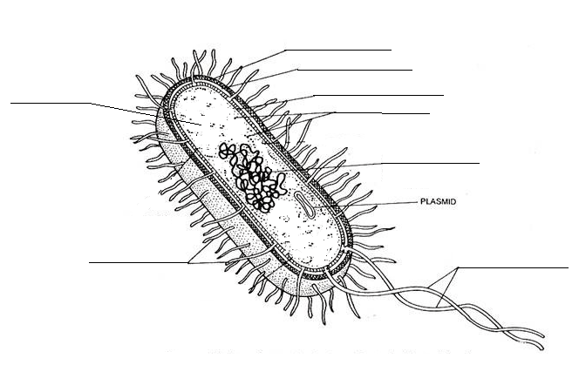
CELL MEMBRANE
CELL WALL
CYTOPLASM
PILI
FLAGELLA
NUCLEOID
RIBOSOMES
CAPSULE
PART B:
- RIBOSOMES
- CAPSULE
- CELL WALL
- NUCLEIOID
- FLAGELLUM (Flagella – Plural)
- PILI
- PLASMID

