Name:_______________________
Date: _______________
Chemistry of Life : Review #5

Biological Molecules (Learning Outcome C-12)

L.O. C-12 – Nucleic Acids and ATP

____1. Name the two major types of Nucleic Acids.
____2. What is the key difference between the two categories, when comparing sugars
(see Table 2.3 in text)
____3. Give the full names for the four nitrogenous bases that are found in DNA
____4. What replaces the THYMINE base in RNA?
____5. List the three key components that all NUCLEOTIDES possess.
____6. If you built an nucleic acid that consisted of 8 nucleotides all in one strand, how
many waters would have been produced during its creation?
____8. A modified nucleotide called ATP is built as an energy molecule for the cell, how
does it differ from the RNA Nucleotide that bears an Adenine base?
____9. Structurally compare ATP to ADP.
____10. What must take place energy to be released from ATP?
____11. What must take place to make ADP into ATP?
____12. Completely label the diagram below with full names:

1._____________________________________________
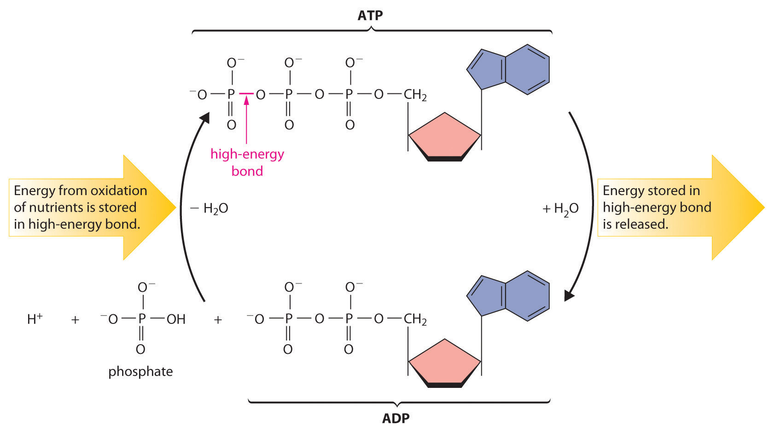
3.______________
2.______________________________

