Unit I Review #1 Q’s – Answer Key
LO I-0
- Physical (Mechanical) and Chemical digestion.

- The final products of digestion are small simple nutrient molecules (monomers) that are capable of being absorbed into the bloodstream.

- For chemical digestion to occur, digestive enzymes and water along with the given substrates must all be present.

- The majority of absorption from the alimentary canal into the bloodstream takes place in the Small Intestine.

- The small intestine has many folds inside and many finger-like projections that stick off of these folds. These projections are called VILLI.
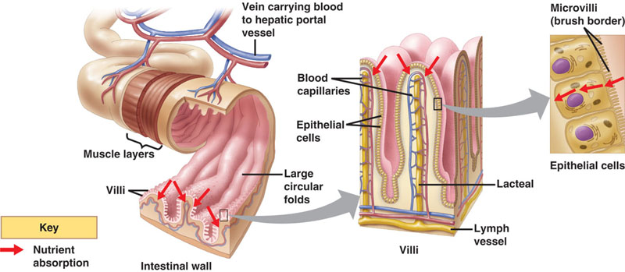
- The digestive system is specialized to absorb Amino Acids, Monosaccharides and Glycerol and Fatty Acids as well as Nucleotides.

- Defecation

LO I-1
- Oral Cavity
- Teeth are responsible for Physical (mechanical) digestion.

- Salivary glands produce saliva, this saliva moistens food and an enzyme (salivary amylase) begins to chemically digest starch.

- The three salivary glands are PAROTID, SUBLINGUAL, and SUBMANDIBULAR.
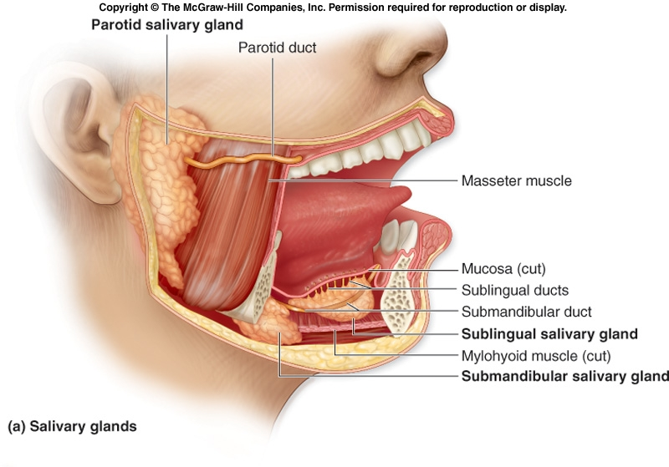
- The tongue helps move food around to the teeth and to the pharynx for swallowing. Along with this physical digestion, the tongue also possesses taste buds.

- The back of the throat is called the PHARYNX

- The EPIGLOTTIS.
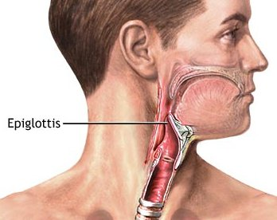
- Peristalsis is the process of moving food through the digestive tract. It occurs through a series of rhythmic contractions of circular and longitudinal smooth muscle lining the digestive tract. This process occurs all along the digestive tract from the esophagus to the large intestine.

- The cardiac (gastroesophageal) sphincter is a ring of muscle that contracts and relaxes to allow food into the stomach from the esophagus and to help try to prevent stomach contents from coming back up into the esophagus.
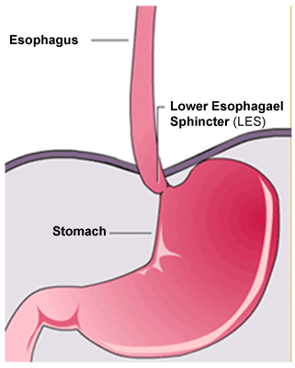
- The stomach is a strong 3-layered muscular J-shaped organ that expands to store food.

- The stomach can physically digest food by using muscle to churn and mix the food with water.

- The stomach can chemically digest food by producing pepsin (enzyme) which chemically breaks proteins down into smaller peptide chains.

- The Pyloric Sphincter.
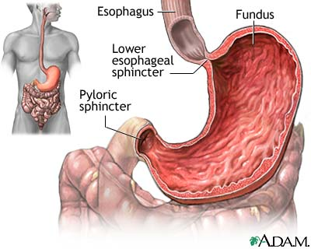
- The duodenum is the first 45 cm of the small intestine.

- Duodenum receives secretions from the following : Liver, Gallbladder, Pancreas, Stomach Contents and from microscopic Duodenal Glands.
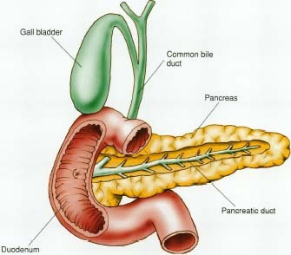
- The liver produces BILE.

- Bile is produced in the liver then stored in the GALLBLADDER.

- Pancreatic enzymes do the following:
- Pancreatic Amylase Starch
- Trypsin Proteins
- Lipase Lipids
- Nucleases Nucleic Acids

- As food leaves the duodenum, it then passes into the JEJENUM and then onto the last section of the small intestine called the ILEUM.
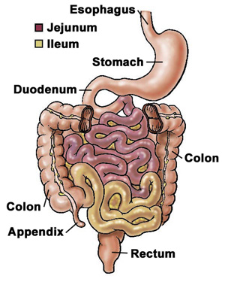
- The main function of the small intestine is to complete chemical digestion and then the remainder of the small intestine is for ABSORPTION of NUTRIENTS.

- Where the Ileum joins the large intestine a cecum is found with an appendix projecting off of it.
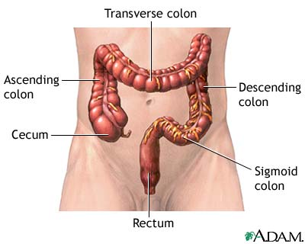
- LARGE INTESTINE or LARGE BOWEL

- The main function of the large intestine is Absorption of WATER. Also to house bacteria which play a role in mineral absorption and vitamin production.

- The Rectum

- The rectum stores and compact feces.
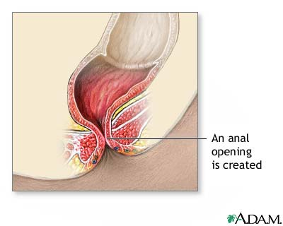
- Anal Sphincter forms the Anus.

