Unit I Review #3 : Answer KEY
LO – I-5
- The Pancreas.

- Insulin directs liver and muscle cells to take up blood glucose and store it as glycogen when blood glucose is too high. This will help lower your blood glucose level.
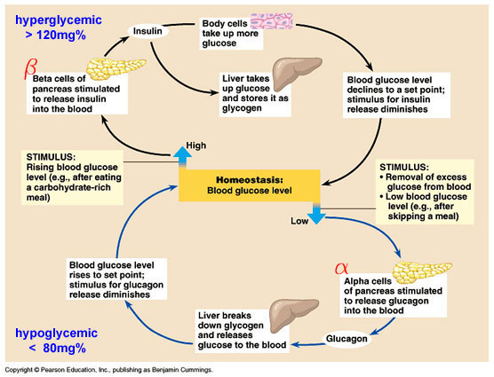
- Excess glucose converts to GLYCOGEN and is stored in muscle and liver cells.

- GLUCAGON – Which tells liver cells to convert Glycogen back into glucose for the blood. GLUCAGON will raise your blood sugar level.

- ENDOCRINE

LO – I-6
- Bile breaks up fat clumps into smaller fat droplets, this is known as emulsification.
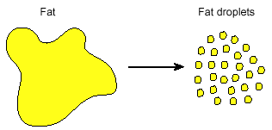
- Bile is produced in the liver.

- Bile is stored in the Gallbladder.
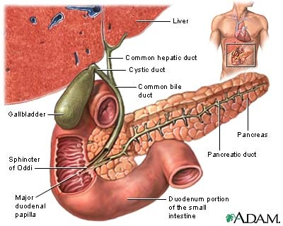
- JAUNDICE.
Jaundice is the accumulation of Bilirubin in the blood as it is unable to be excreted with the bile. Some causes could be: blocked bile ducts, blood infections that cause Hemolysis (rapid rupturing of red blood cells), or overall liver failure (Hepatitis). Symptoms include yellowing of the skin and scleras (whites) of the eyes.
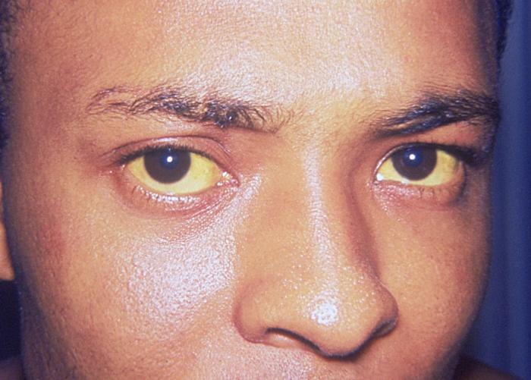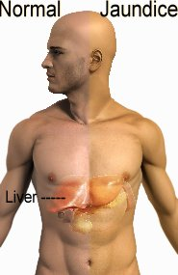

LO I-7 - Key Functions covered in earlier review:
- Detox, Production of Plasma Proteins, Manufacturing and excretion of Cholesterol, Production of Bile, Receive and process sugars and amino acids, Deamination (Converting ammonia into urea), Blood glucose homeostasis. Red blood cell recycling.

- Blood GLUCOSE Concentration

- Amino groups are taken off of amino acids and ammonia is produced, then 2 ammonia molecules are combined with one carbon dioxide molecule to form UREA.
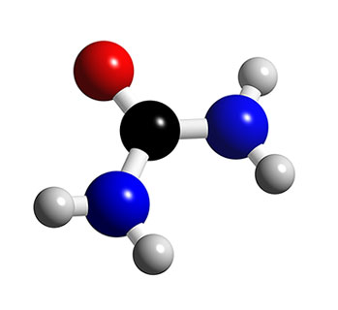
- Vitamins A, D, E, K are all Fat Soluble.

- The liver manufactures important plasma proteins. Some of these plasma proteins are important for proper blood clotting.
LO I- 9
- The small intestine uses Plicae, Villi and Microvilli to increase surface area for adequate absorption.
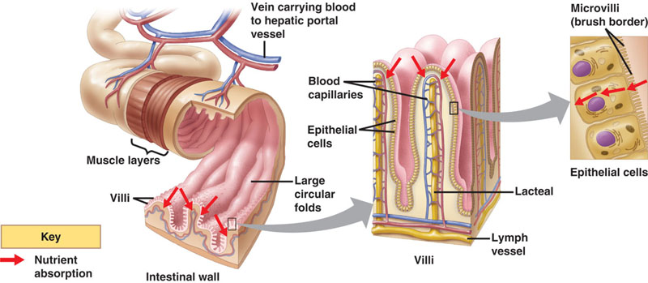
- Amino Acids, and Monosaccharides (glucose) are absorbed into the capillary bed. The other function of this capillary bed is to drop off oxygen and processed nutrients to these hard working cells of the villus.
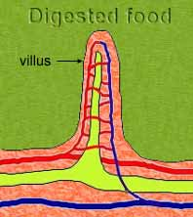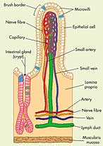
- Lacteals absorb the products of fat digestion.

- Active Transport would be required to move substances from the lumen of the small intestine into the blood, as we want to absorb all of the nutrients.

- The HEPATIC PORTAL VEIN.

- Nucleosidases break Nucleotides down into the separate Pentose Sugar, Phosphate Group and Nitrogenous Base.

LO – I-10
- The bacteria in the large bowel are important for : A) Production of some vitamins (Vit K)
B) Breaking down indigestible wastes to free up other vitamins and minerals.
C) These bacteria colonize the gut and prevent the overgrowth of harmful bacteria.
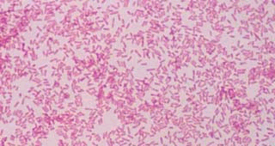

- FLATULENCE – Gas – Fluffs – Farts Etc.
- Vitamin K

- Vitamin K plays an essential role in Blood Clotting.

- Diarrhea. If diarrhea is severe or prolonged an individual may become dangerously dehydrated.

PRACTICE QUIZ KEY:
- A – Structure V is the gallbladder, which stores Bile.
- B – The liver can take up glucose and store it as Glycogen and then break it back into glucose and put it back into the blood. It does this under the control of pancreatic hormones Insulin and Glucagon.

- C – the membrane is impermeable to peptide chains but it would be permeable to smaller molecules like water and amino acids. As Peptidase is added to side A, the peptidase enzyme will break the peptide chains into individual AA,s. These AAs will then move from an area of high concentration (side A) to an area of low concentration (side B)

- B – "X" has a pH of approximately 2.5, the only place with that low of a pH would have to be the stomach.

- C – The optimal pH for this graph is approximately a pH of 8.5.

- D – Bile spreads fats out, but it is NOT an ENZYME !!!!! so it does not chemically change fats!!!!

- D – Peptidases produced from the duodenal exocrine glands will work on peptide chains down the length of the small intestine.

- D – The enzyme maltase produced the duodenal exocrine glands will work on breaking 1 Maltose 2 Glucose in the small intestine.

- C – without sodium bicarbonate to neutralize the acidic chime that enters the small intestine, the acid would both denature all the new incoming enzymes as well as irritate the poorly protected intestinal wall.

- C – Salivary amylase and Pancreatic amylase break starch into maltose molecules.
They work well between a pH of 7 (mouth) and
7.5 8.5 (small intestine). The optimal temperature for most enzymes is approximately 37 Celsius.
- Test Tube #1 is too cold like a fridge which slows down enzymatic activity
- Test Tube #3 is close to opitimal temperature and pH is in the zone, it also has the most substrate
- Test Tube #4 is too acidic causing denaturation
-Test Tube #2 only has 1 ml of starch but the pH is pretty close to optimal, but the temperature is not near the optimal.

