Name: __________________
Date: __________
Unit J Notes #2 : CIRCULATION

A) OVERVIEW
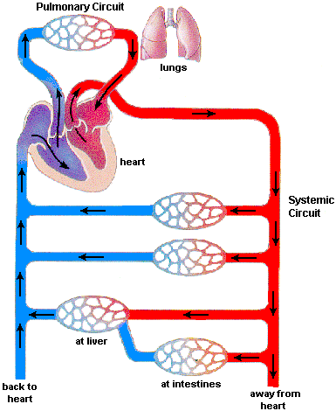

B) _________________CIRCUIT:

- Path that connects the__________________________, blood is sent from the heart to the lungs and then back to the heart.

Pathway : ______________________________________________________________
_______________________________________________________________________
_______________________________________________________________________
_______________________________________________________________________
_______________________________________________________________________

-Carries carbon dioxide-filled blood to lungs for _____________________

-_______________________________________ to heart so that it can be pumped out to systemic circuit.

C) _______________CIRCUIT:

- Path from Left Ventricle out ____________________________________________

and then__________________________________________________.

- Carries oxygen rich blood to body tissues.

- Returns carbon dioxide filled blood back to the heart.

D)_______________________________________:

- Fetal systems have _______________features not present in Adult Systems:

See Animation:
http://www.youtube.com/watch?v=uwswhoKfkmM

1. __________________________

- ____________________________________.
- It is covered by a flap of tissue that acts like a valve.

- Blood flows directly from the ___________________ to the ___________________.

-__________________________, which do not work yet.

2. __________________________

- _______________________between the Pulmonary Artery and the Aorta.

- Blood flows from the Pulmonary Artery to the Aorta, again __________________
the lungs.

3. UMBILICAL ARTERY AND VEIN
- ______________________________________________(Carbon Dioxide and Urea )

___________________________.

- ______________________________________________ (Oxygen and Glucose and

Amino Acids) _______________________from the Placenta.

4. VENOUS DUCT
- A connection between the________________________________________________.
-Blood from the placenta passes directly into the liver through this duct and from there, to the right atrium of the heart.

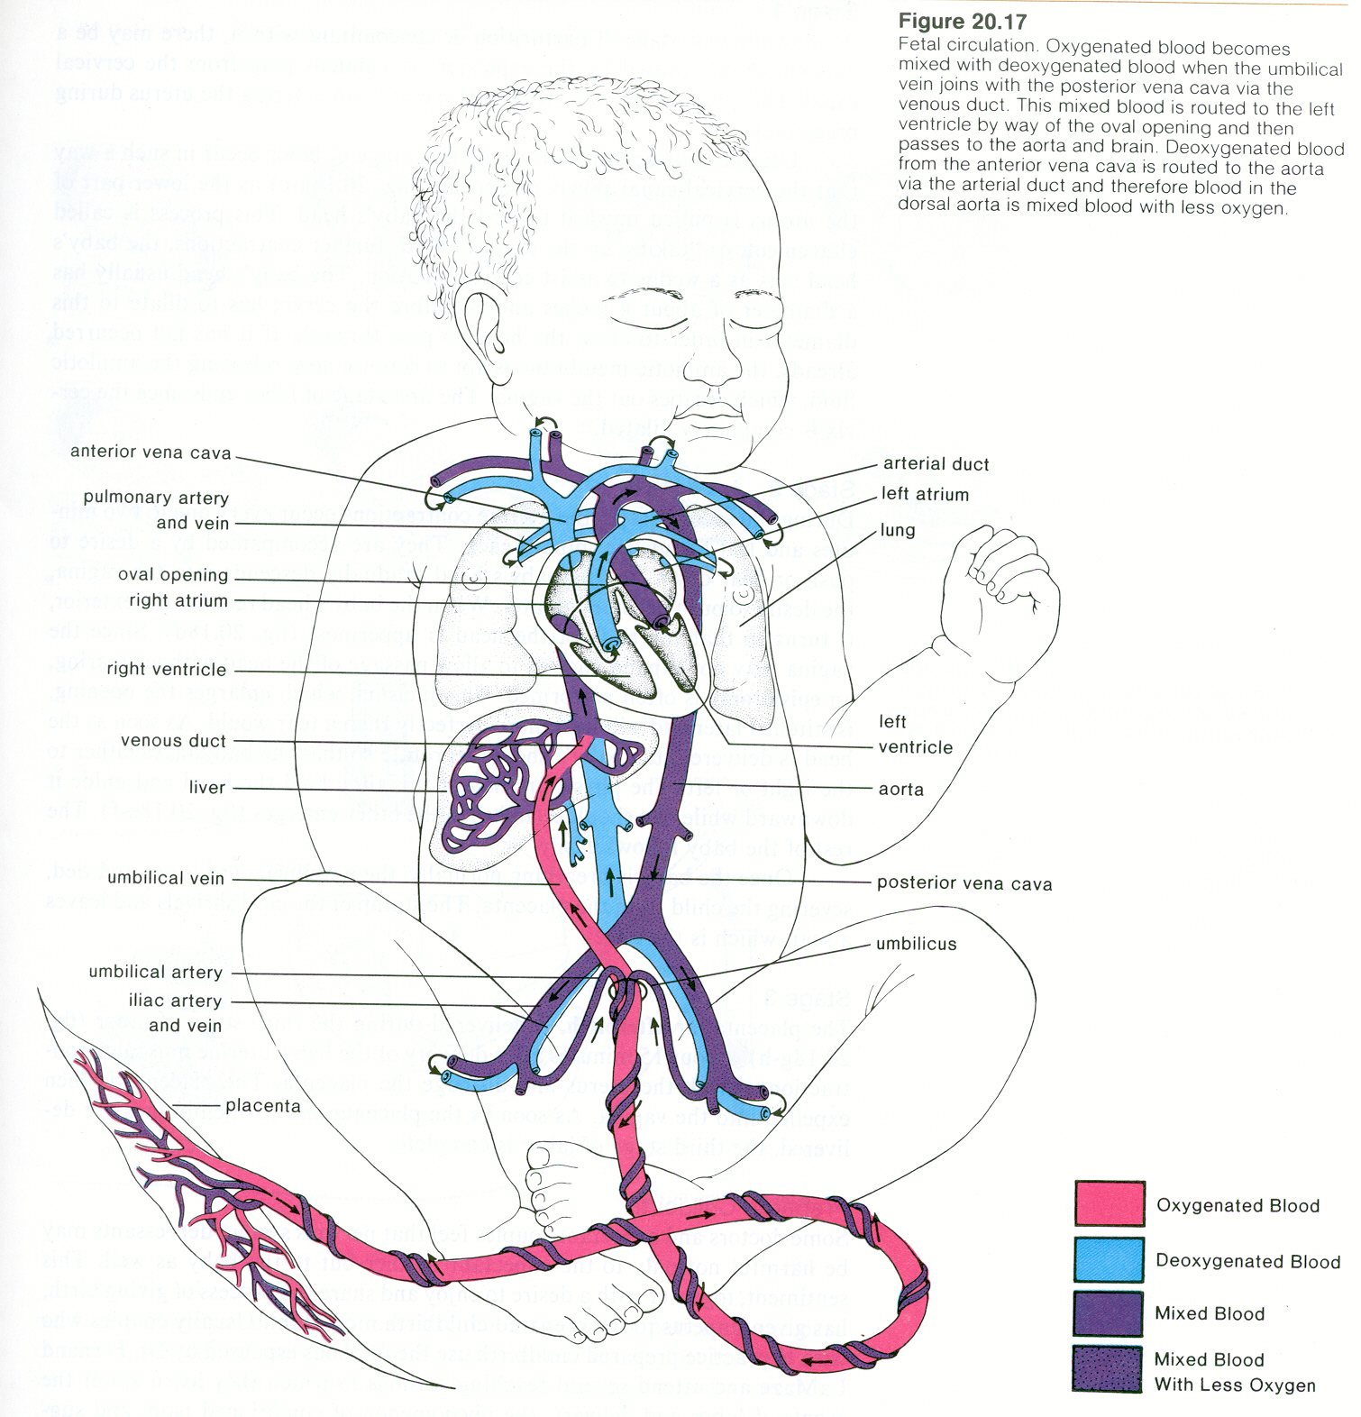

E) PATH OF A BLOOD CELL THROUGH THE BODY

- Start in the Left Ventricle and go through the Circulation System
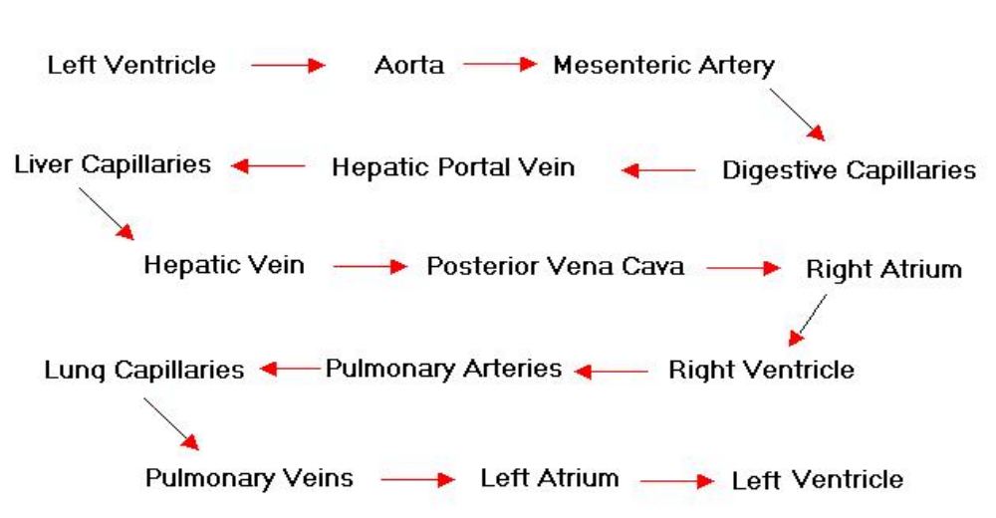
- The whole trip takes about 30 seconds.

