Unit O Notes #2 : Nephrons and Urine Formation

KIDNEY Functions :
i) Excrete nitrogenous wastes.
ii) Help regulate blood pH.
iii) Maintain water-salt balance in blood. (blood
pressure)
iv) Also have a hormonal function.

A) Nephron Structure inside Kidney:
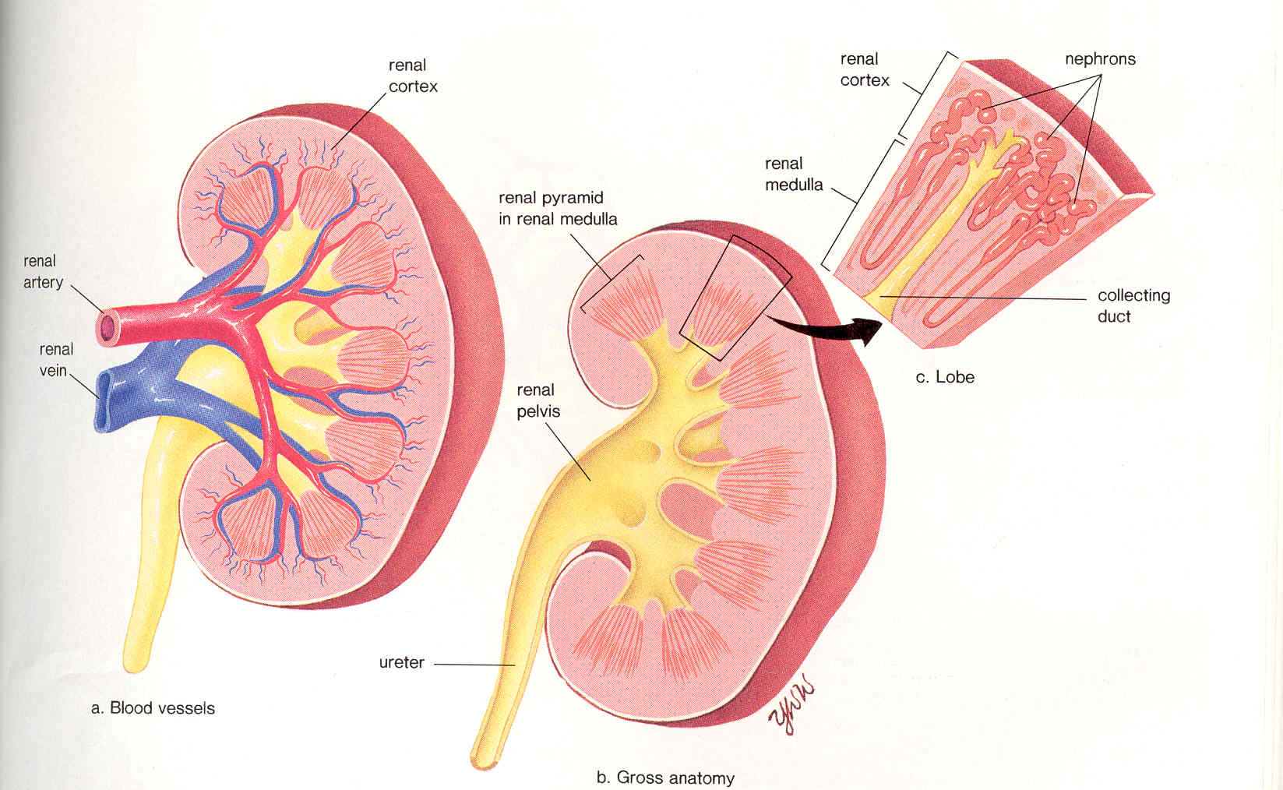

- Microscopically, the kidney is composed of over one million nephrons (or renal tubules)

- Each nephron has two capillary regions in close proximity to the nephron tubule, the first capillary bed for fluid exchange is called the glomerulus, this is found inside a structure called the Bowman’s capsule.
- The second capillary bed for fluid exchange is found around the rest of the nephron tubule, this is called the peritubular capillary network.

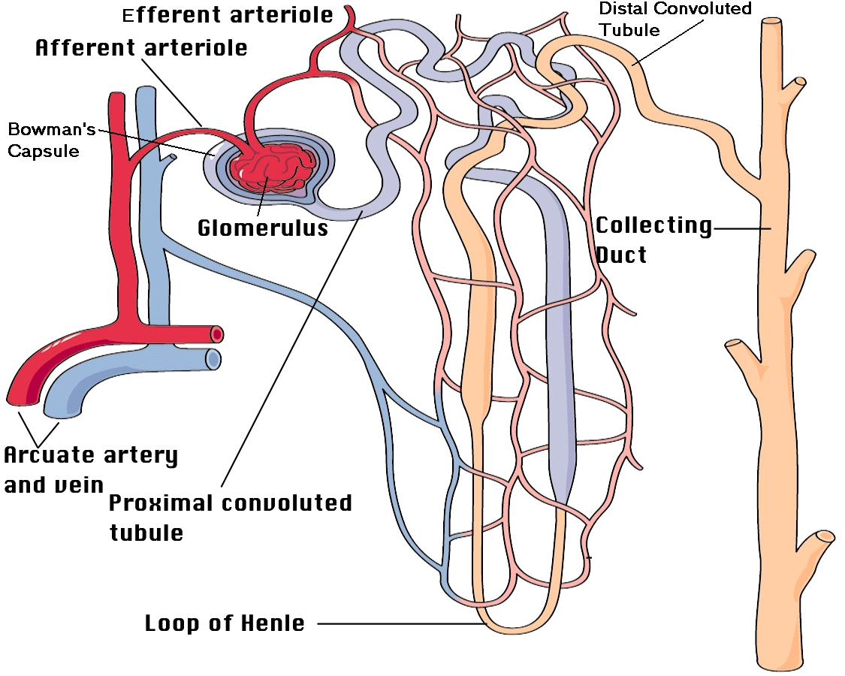
Peritubular Capillary Network

NOTE : ** “Arcuate” means curved, many parts of the body have arcuate arteries and veins.
- The Bowman’s capsule( (1) and proximal convoluted tubule (2) are located in the cortex of kidney.

- Loop of Henle (3) dips down into the medulla of kidney.

- Distal convoluted tubule (4) back up in the cortex.

- Collecting ducts (5) are located running from the cortex into the medulla (most of duct is in the medulla)
- Afferent is a Latin word that means bringing toward. (Afferent = Arriving)
- Efferent is a Latin word that means carrying away.
(Efferent = Exiting)

- These terms are used to describe the arteriole (afferent) going toward the Glomerulus and the arteriole (efferent) going away from the Glomerulus.

B) Urine (95% water) Formation:
- Renal Artery – Brings blood to the kidneys to be “cleaned”. Blood is high in urea (product of the deamination of NH₃ from amino acid molecules)
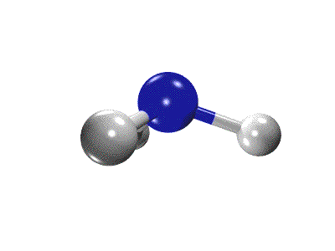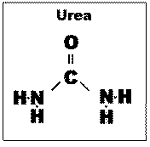
Ammonia (NH₃)

- Renal Veins – Returns clean blood back to the inferior vena cava. Much lower urea content in this blood.

Tracing the Formation of Urine – Five Key Steps
a. Glomerular Filtration (pressure filtration)
b. Tubular Reabsorption (selective reabsorption)
c. Tubular Secretion (tubular excretion)
d. Water Reabsorption
e. Excretion of Urine
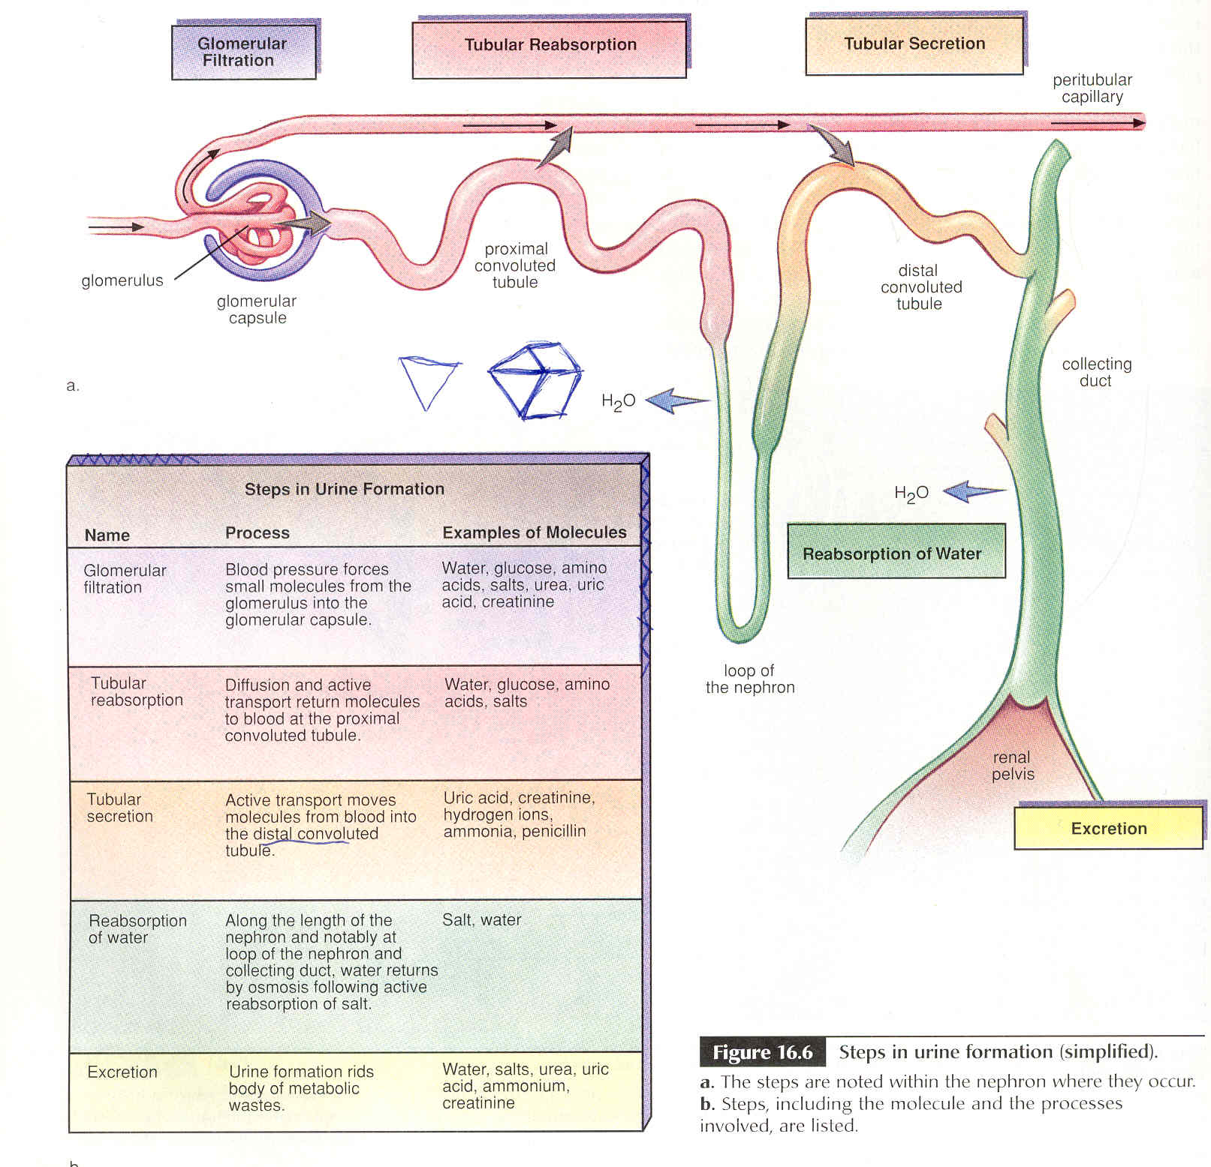
a) Glomerular Filtration: First, blood from renal arterioles (afferent) enters the many Glomeruli, each of which is surrounded by its own Bowman’s capsule. Here, Pressure Filtration occurs due to high blood pressure in the glomerulus. Most small molecules like water, ions (Na⁺, K⁺, Cl⁻ ) nutrients (glucose and AA’s), and wastes enter the Bowman’s Capsule. Large organic molecules and formed elements do not enter as they remain behind as to form the filtered component. The liquid that does pass into the nephron tubule forms the filtrate. This filtrate is basically blood plasma minus the large blood proteins.

Filterable Blood Non-Filterable Blood
Components: Components:
Water Formed elements-
Nitrogenous Wastes (blood cells and platelets)
Nutrients Proteins
Salt (ions)

- Blood pressure is very important. If blood pressure is too low, proper filtration will not occur. An enzyme called Rennin is released from a specialized tissue in the Glomerulus that causes the constriction of the Glomerulus thus the blood pressure is increased to an adequate level.

b) Tubular (selective) Reabsorption is the process of passively and actively reabsorbing the good stuff (water, glucose/AA’s, majority of ions like Na⁺, and Cl⁻) back out of the filtrate and returning it back into the blood. This process occurs primarily between the proximal convoluted tubule and the peritubular capillary network. Most reabsorption requires active transport using ATP to maintain pumps. After concentration gradient is established water and some ions can passively pass back into the blood.

c. Tubular Secretion (excretion) is the second process whereby wastes enter the fluid space of the nephron. This time excess molecules in the blood, such as H⁺ ions, Histamines, Penicillin, Creatinine and Ammonia are actively secreted into the distal convoluted tubule from the blood of the peritubular capillary network. This active transport plays a role in helping to maintain homeostasis, like blood pH.

d. Reabsorption Of Water: The body cannot afford to lose too much water, much of the water in the filtrate must be reabsorbed into the blood. (*If not you would urinate out 180 liters of pee per day → DEATH)

This reabsorption of H₂0 is driven by osmosis due to concentration gradients.

- The loop of Henle has a descending limb and an ascending limb. The ascending limb is thicker near the top part of the limb.
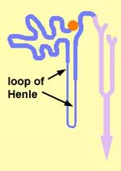
Ascending Limb

Descending Limb
See Animation:
http://www.youtube.com/watch?v=glu0dzK4dbU&feature=related
- As the filtrate moves through the bottom of the loop and up the thin first part of the ascending limb salt (NaCl) and other solutes passively diffuse out into the tissue of the inner renal medulla.

- To further extrude salt out of the filtrate, cells lining the thicker upper portion of the ascending limb, use active transport to pump NaCl out into the tissue of the outer renal medulla.

- This creates a solute concentration gradient from the renal cortex down into the inner renal medulla as illustrated below:
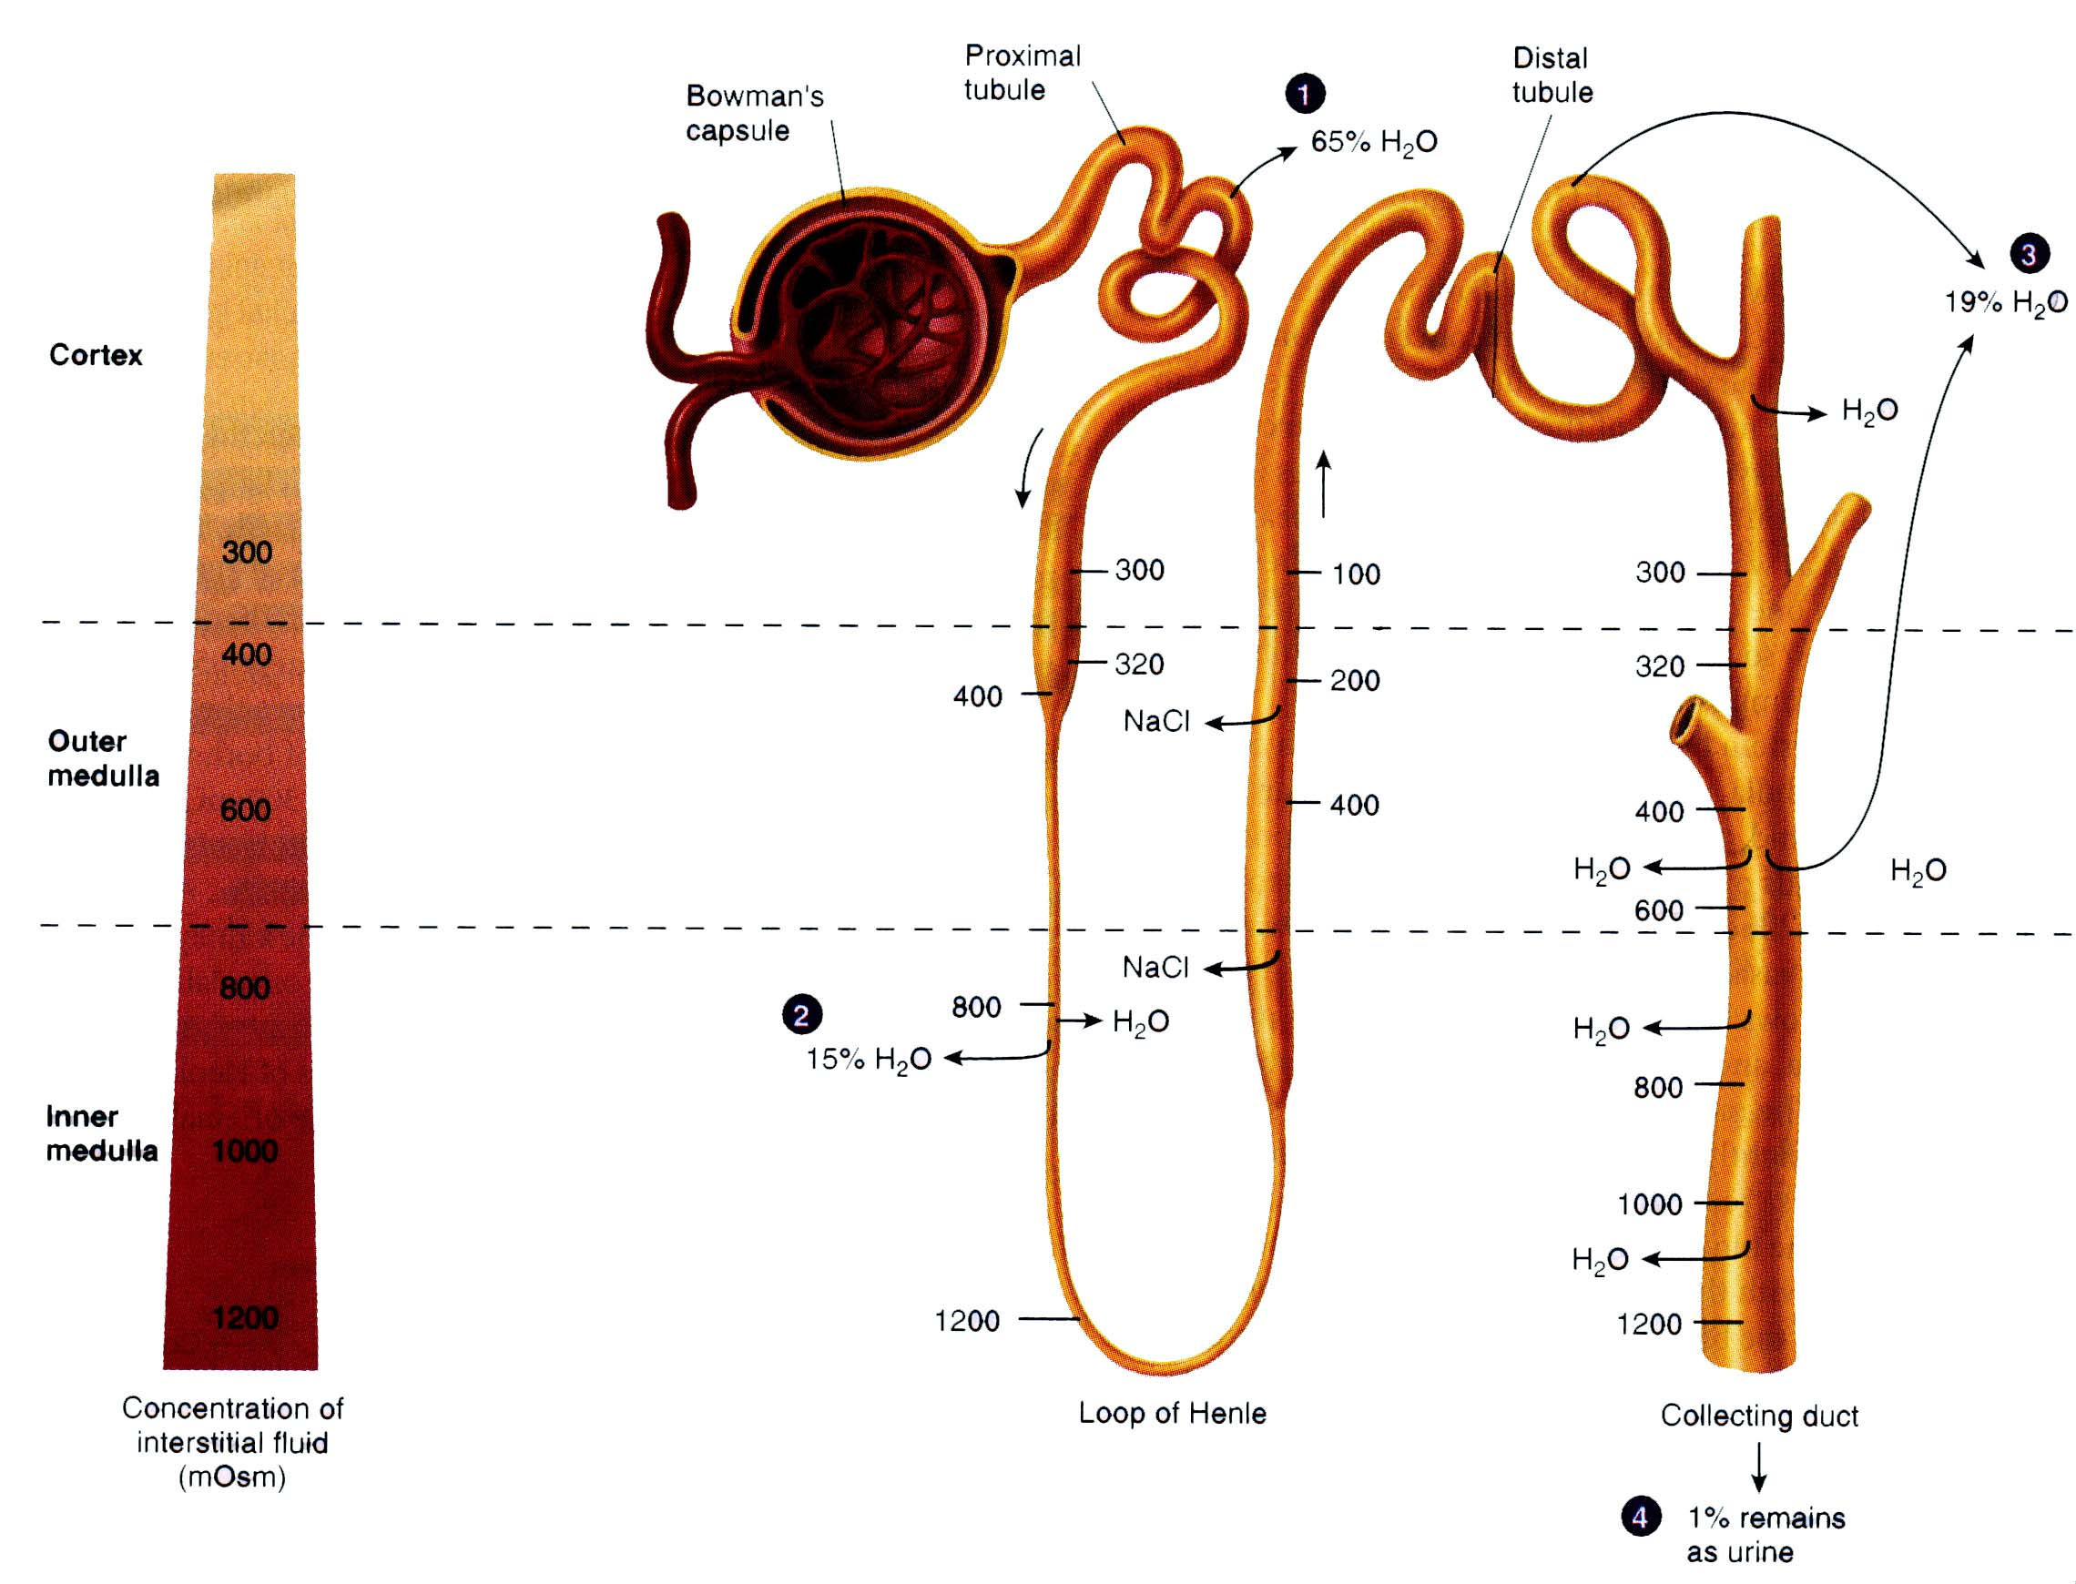
- This established concentration gradient drives the osmosis required to reabsorb water from the filtrate as it moves down the descending limb of the loop of Henle and also as the filtrate moves down the collecting duct.

* Remember how water flows on land: Always down hill; likewise in the nephron water flows out down the descending limb and out as it goes down the collecting duct.

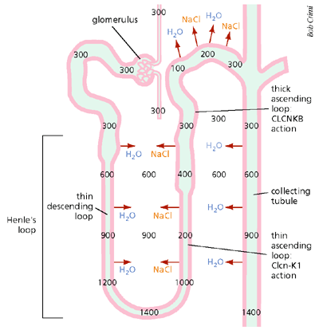
e) Excretion Of Urine: Concentrated (Hypertonic) Urine from the collecting tubules collects down in the Renal pelvis; from there it will drain down through the ureters to the urinary bladder.

